OVERVIEW: Occasionally classes are offered that do not fall within the established terms as defined by the college’s academic calendar. These classes are defined as crossing terms. These guidelines are designed to ensure that the FTE is awarded to the appropriate term. In this way, we can accurately determine benefits, step increases, 60% FTE, Preferences and other practices that are impacted by FTE.

Classes that cross terms are generally offered by the Public Safety Center, The Training Source and UCD. When these classes are taught by instructors that are hired by Los Rios, a TCS is generated.

PURPOSE: The purpose of this document is to describe procedures for processing TCS assignments that cross terms for those that have a good understanding of processing TCSs.

This document will describe:
- Characteristics of Classes that cross terms
- Inputting into PeopleSoft classes that cross terms
- Processing TCSs that cross terms
- Hiring Cross Term Classes

I When Do Classes/Assignments Cross Terms?

These rules apply to adjunct and overload assignments that are supported by a TCS agreement. The rules to determine by semester if a class crosses terms are described by term in the following:

Fall: Fall term assignments beginning on or after the first instructional improvement day (flex) and end prior to January 1st.

Any portion of the assignment that occurs before the Fall First Instructional Improvement Day will be computed on a TCS for the summer term.

Any portion of the assignment that occurs on or after January 1st will be computed on a TCS for the spring term.

Spring: Spring term assignments begin on or after January 1st and end before the first day of instruction for the summer term

Any portion of the assignment that occurs before January 1st will be computed on a TCS for the fall term.

Any portion of the assignment that occurs on or after the First Day of the Summer Instruction Begin Date will be computed on a TCS for the summer term.

Summer: Summer term assignments begin on the Summer Instruction Begin Date described on the Academic Calendar and end before the First Instructional Improvement Day (flex) of the fall term.

When a class begins after the Last Semester Day of spring, the assignment will be computed on a TCS for the summer term.
When a class begins within the spring term and ends before the first day of the summer term, the assignment will be computed on a TCS for the spring term.
Any portion of the assignment that occurs after the First Instructional Improvement Day of the fall term will be computed on a TCS for the fall term.

Note: The key to remember is that if the class begins in the spring term and ends before summer session begins, it is a spring semester class; if the class begins after the end of spring semester but before the beginning of summer session, it is considered a summer assignment.

II Inputting Classes into PeopleSoft That Cross Terms

There are two methods to assign instructors to classes in PeopleSoft that generate a TCS:
1. Schedule of Classes: Instructors for Meeting Pattern
By term, college and class
- Term Workload: By Employee (emplid) and Term

In order for a class to show up on the Class Schedule, it must be input in the Schedule of Classes. Therefore, if the class is to be listed in the schedule for a specific term, add the course to the Schedule of Classes. Include the other ‘cross term’ portion in the Term Workload.

Follow the normal process of inputting a class and assigning an instructor on the Schedule of Classes: The ending and start dates will be the true dates the class will be offered. (Note: Dates will be adjusted on the TCS start and end dates).
Adjust the Work Load to reflect the correct Assignment FTE% that applies to this term.
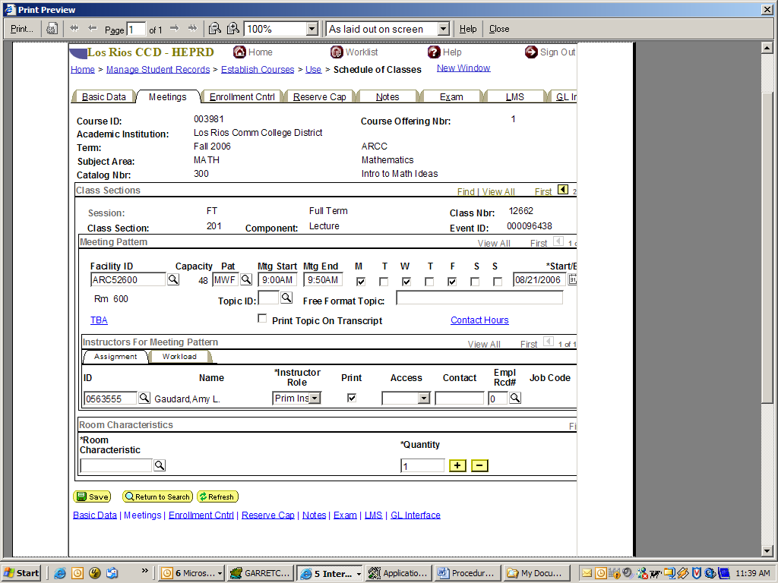

Add the other term to the Term Workload:

Location: The location is the same as the location on the Schedule of Classes.

Description: In the Description field enter the CT, Subject, Catalog Number, and Term where the Schedule of Classes is assigned.

For Example: CT is for Cross Term, Subject is Math, Catalog Nbr is 300, and Term is 1069:

CT, Math, 300, 1069

Assign Type: there are four assignment types:
Lab – Reg (Labs for Adjunct faculty)
Lec – Reg (Lecture for Adjunct faculty)
Lab – Ovl (Labs for Overload assignments)
Lec – Ovl (Lecture for Overload assignments)

Work Load: Determine workload according to established procedures. Split the Work Load appropriately between both semesters. Select the workload that determines the Assignment FTE % most accurately.

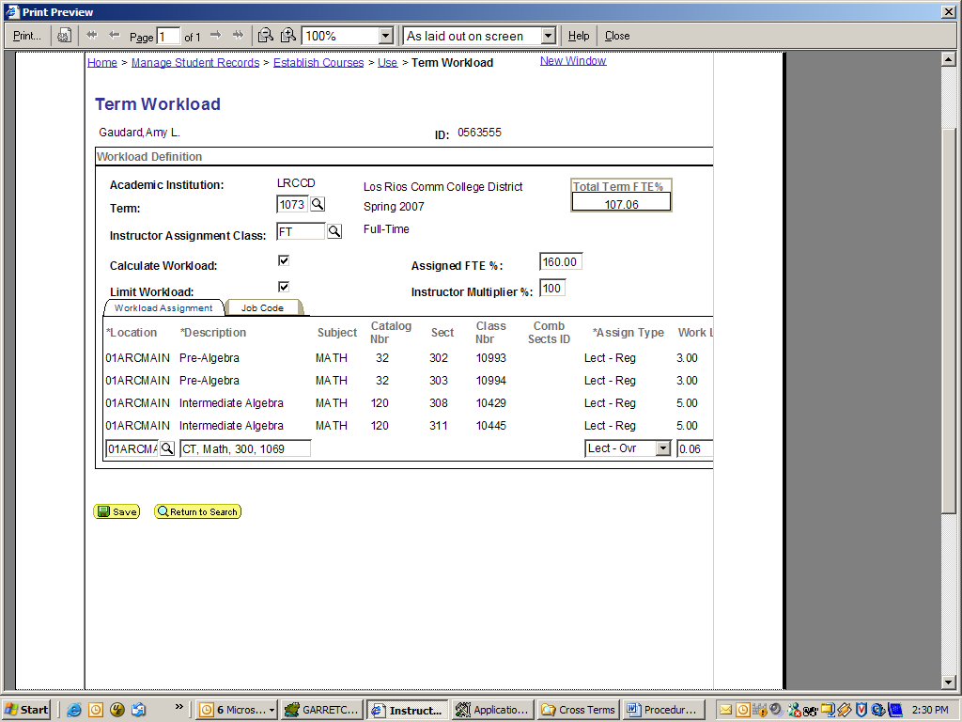
Below is the SA Ready TCS
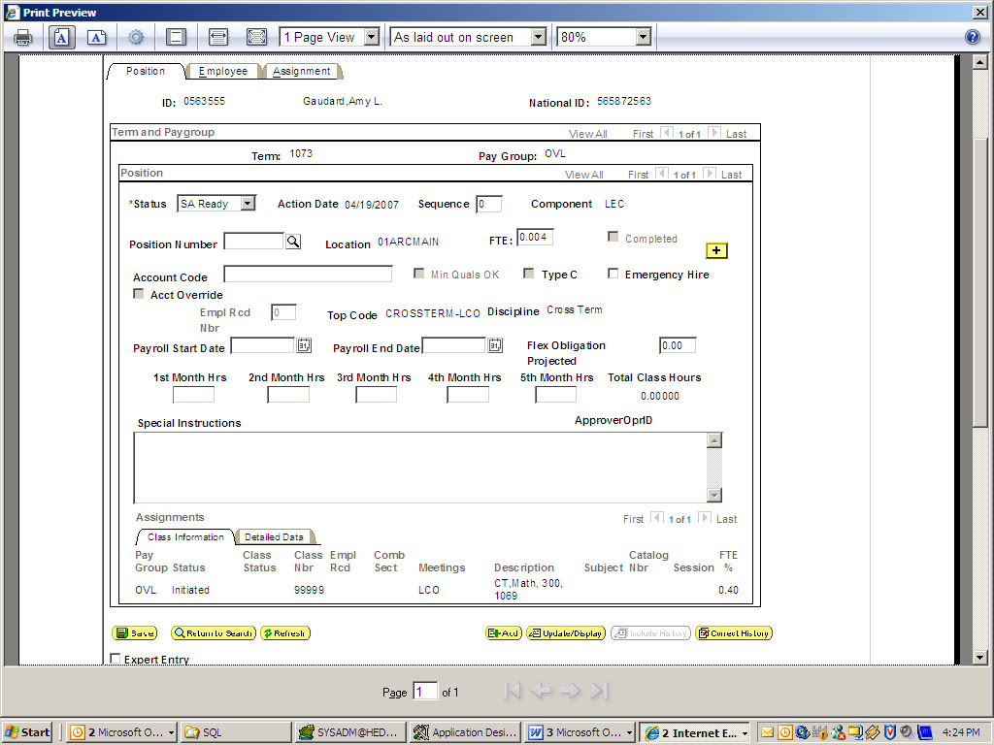
When preparing the TCS include in Special Instructions the Discipline that is on the original TCS. In this example the original TCS has ‘Mathematics, General’ for the discipline. This gives HR the information needed to validate Minimum Quals.
Enter a comment in Special Instructions: ‘Discipline: Mathematics, General’.

III Processing a TCS in the SA Work Queue that Crosses Terms

A TCS record is created when:
- An instructor is added to the Schedule of Classes, Instructors for Meeting Pattern.
- When a class is added to Term Workload based on the Assignment Type. The assignment types listed above will result in a TCS

The TCS will display in the SA Work Queue, pending completion by the TCS Technician.

Note: TCSs for any term will not show/display until the term is opened by the college. Therefore if a cross term course falls into a future term and the future term has not been ‘opened’ it will not be displayed in the work queue until the college opens the term.

For Example: If a class is assigned in June for the following fall term (example: start date in March) and it crosses into the summer Term (example: ending date in July), the class portion assigned to the summer term will not display in the SA Work Queue until the college opens the summer term. Therefore, special attention may need to be made by the TCS Technician to manage TCSs for future terms.

On the following page there is a copy of the TCS SA Work Queue. Follow established procedures for completing TCS, with the following adjustments:

1. FTE: Adjust the FTE to represent the FTE for the current term only.
2. Payroll Start Date & Payroll End Date: To be inclusive of the current term only.
3. Special Instructions:
Type a note in Special Instructions that states this assignment crosses terms:
Example: This TCS will cross into the next spring term (1073) with .5 FTE. Ending Date will be February 2, 2007.
When the next term TCS is worked, another similar note will be entered into Special Instructions related to the first TCS.
Example: This TCS was a cross over with the previous fall term (1069) with .2 FTE.
Include the discipline in the special instructions that is displayed on the original TCS.
Example: Discipline: Mathematics, General

The spring term TCS will be completed when the spring term is opened by the college. If both terms are open and both TCSs are available to work, work them at the same time.

IV Hiring Cross Term Classes

The HR Work Queue will continue to trigger creating a JOB record. The TCS will show the correct Payroll Start and End Dates based on the TCS Position page. The FTE will also accurately reflect the FTE for that term. HR will be notified the job assignment crosses terms by the notes in the Special Instructions. HR will follow the same process followed with other TCSs.

