Los Rios Community College District
Budget Timeline and Allocation Processes
2021-22
Key: | Following Fiscal Year (FY) | Current FY

Month | Level of Control | For Fiscal Year | Activity | Notes | Additional Notes | District Budget Committee (DBC)
JANUARY | State | Following Fiscal Year (FY) | The budget process begins in January with the release of the Governor’s proposed budget for the upcoming year. The January proposal reflects the Governor's goals and objectives for the forthcoming year and highlights significant issues, policies, and initiatives of the Administration | January 2022 State budget process begins for fiscal year 2022-23 | After initial budget proposed, other parties weigh in on the allocations, including the Department of Finance, Legislative Analyst’s Office, Board of Governors, Faculty Associate of Ca. Community Colleges, and other influential groups | Update of State budget presented to the District Budget Committee (DBC) by the Vice Chancellor, Finance & Admin. (VC)
JANUARY | Colleges | Current FY | Final college allocations received in December and Colleges use their process to allocate funds locally | Exact timing and process may vary by College. This allocation is from the 20% of the budget not allocated to the units. | Allocations include College Discretionary Funds (CDF), Program Development Fund (PDF), Lottery and State Instructional Equipment Fund (SIEF)
MAY | State | Following FY | At the May Revise, the Governor updates his initial proposal to reflect changes in projected revenues as well as appropriations, which generally are the result of dialog and negotiations with the State’s legislative bodies following the January proposal | May 2022 State budget revision for fiscal year 2022-23 |  | Update provided to DBC by VC
MAY/JUNE | Colleges | Following FY | Colleges allocate budget for next FY using estimates | Initial budget established at the College level (e.g. – CDF, lottery, SIEF, carry over)
JUNE | State | Following FY | With the issuance of the May Revise, the legislature begins its final budget process which, by law, is to result in a budget by June 15th for the Governor to sign by June 30th | June 30, 2022 State budget for fiscal year 2022-23
JUNE | District | Following FY | Tentative Budget developed and presented to Board of Trustees | Includes our base continuing budget - ongoing known expenses and revenues | Governor’s May Revise is the basis for dollar amounts.  The BOT is required by law to adopt a tentative budget for the upcoming fiscal year no  later than July 1st | Includes updates provided to DBC at May meeting
JULY | Colleges | Following FY | Allocation of college categorical funds (fund 12) | Most grants and categorical funding are allocated at the college level
SEPTEMBER | District | Current FY | Adopted Budget developed and presented to Board of Trustees (BOT) | Includes ongoing and new expenses and revenues as well as carryover amounts | Must be approved by the BOT before 9/15 | Adopted Budget presented to DBC
DECEMBER | District | Current FY | Program Development Funds (PDF) allocated based on existing commitments, committee and Executive Staff requests, facility and LRPD needs. Allocations are presented to VPAs, District Budget Committee & Board of Trustees | 20% of revenues from “bucket” concept allocated to college and districtwide efforts | This 20% of new revenues are used to fund increases in operational costs,  including utilities, some new classified positions, new management positions charged to the unrestricted General Fund, increased costs for supplies and materials,  as well as program improvement costs | PDF presented to DBC

Not shown above are budget revisions to the adopted budget, usually taken to the Board in January or February and June. These revisions are needed when the initial budget has been based on estimates and the actual expense or revenue is established through State allocations, or other sources.

Acronyms

CDF – College Discretionary Funds
College Discretionary Funds are allocated in support of operational costs at the colleges for instructional, student services and administrative activities. A formula consisting of a base allocation and four factors tied to operational needs of the colleges are used in the allocation. The four allocation factors are Average WSCH (Spring, summer, fall terms), Maintenance & Supplies (Total Square Footage (TSF)), Facility Utilization (Utilized Assigned Square Feet) and Staff Development (Authorized FTE).
The colleges allocate these funds using their internal processes. Allocation to the colleges for fiscal year 2021-22 was as follows:
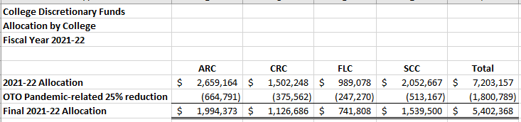

SIEF – State Instructional Equipment Funds

Instructional Equipment and Library Materials (SIEF&LM) – amounts allocated as Scheduled Maintenance/Scheduled Repairs (SMSR) and SIEF by the Governor in the State budget. The District Budget Committee reviews the allocation split of these funds.

SIEF funds are allocated to the Colleges and they in turn use their internal processes to allocate to the college. Allocation to the colleges for fiscal year 2021-22:
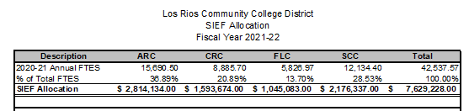

Allocation Methodology
Our “Bucket” Concept model identifies new sources of revenue received annually, including:
1. Growth funds;
2. Cost of living adjustments (COLA);
3. Other Program Based Funding revenues when appropriated;
4. Program improvement funds, including equalization dollars;
5. Lottery revenues;
6. Cost reductions and/or salary savings (decrements).

Eighty percent (80%) of these new funds are allocated to the respective collective bargaining units based upon a proportionate share. In Fiscal year 2020-21, the proportionate share for each bargaining unit was LRCFT – 62%, LRCEA – 20%, SEIU - 6%, LRSA – 3%, Confidential and Management - 9%. So, for example, LRCFT receives nearly 62% of 80% of the new revenues identified above, LRCEA receives 20%, etc.

While this methodology ensures equity in distribution of 80% of our resources, it limits the District’s operating revenue on an annual basis to 20%. It also limits growth in the District’s ending reserve.

2020-21 Actual Expenditures from the 2021-22 Adopted Budget Book
General Fund, restricted and unrestricted

Academic and Classified Salaries and Employee Benefits equal 78% of the General Fund (unrestricted & restricted) budget.
2020-21 Actual Expenditures
General Fund

Categorical Funds
Allocation Method
Fiscal Year 2021-22
*HEERF Funding included in fiscal year 2021-22 revenue is $156 million

